REMOTE SYSTEM HEALTH MONITORING

1. Problem Statement:
In a computer network, multiple systems may be connected at different locations. It is difficult for an administrator to manually check the health and performance of every system.
Each system may experience problems such as high CPU usage, high memory consumption, too many running processes or network-related issues. If these problems are not identified on time, they may affect system performance and availability.
The Remote System Health Monitoring project aims to develop a centralized monitoring system that collects health information from multiple systems and displays it at a central monitoring server.
Python socket programming is used for communication between monitoring agents and the central server. Mininet and Software Defined Networking (SDN) are used to create and manage a simulated network environment.

2. Objectives:
The main objectives of this project are:
- To develop a centralized system for monitoring multiple computers.
- To collect CPU usage information from different systems.
- To collect memory usage information.
- To monitor the number of running processes.
- To collect network statistics.
- To transmit system health information using UDP socket programming.
- To receive and display monitoring information at a central server.
- To create a simulated network using Mininet.
- To connect the Mininet topology with an SDN controller.
- To test communication between multiple agents and the central monitoring server.

3. Architecture:
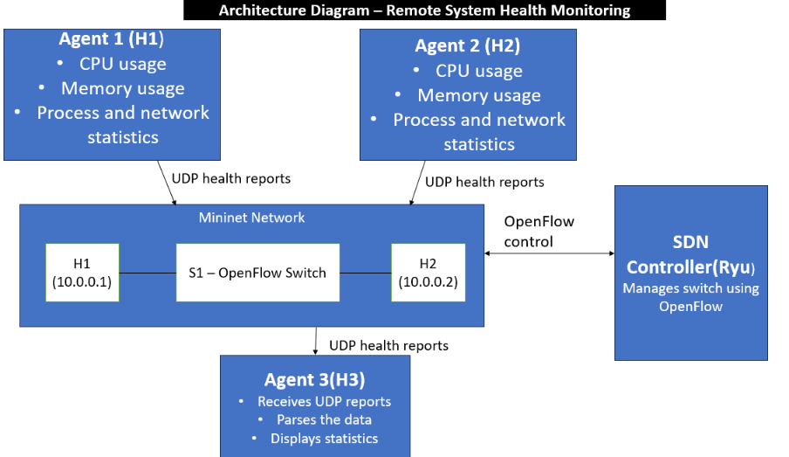

4. Technologies Used
The following technologies are used in this project.
Technology | Purpose
Python 3 | Implementing monitoring agents and server
UDP Sockets | Communication between agents and server
Mininet | Creating a virtual network topology
Open vSwitch | Providing virtual network switching
SDN Controller | Managing switch forwarding rules
OpenFlow | Communication between controller and switch
Ubuntu | Development and execution environment
GitHub | Sharing and managing project source code

5. Python Socket Implementation
Python socket programming is used to establish communication between monitoring agents and the central monitoring server.

5.1 Monitoring Agent
The monitoring agent is responsible for collecting and sending system health information.
The general working procedure is:
- Start the Python agent program.
- Collect system statistics.
- Prepare the monitoring information.
- Create a UDP socket.
- Send the monitoring message to the server IP address and port.
- Repeat the process at regular intervals, if configured.
The monitoring message may contain CPU usage, memory usage, process count and network statistics.

5.2 Monitoring Server
The monitoring server receives information from the agents.
The general working procedure is:
- Start the server program.
- Create a UDP socket.
- Bind the socket to the configured IP address and port.
- Wait for incoming monitoring messages.
- Receive the messages from agents.
- Process and display the received information.
- Generate warnings when configured resource thresholds are exceeded, if implemented.

5.3 UDP Communication
UDP (User Datagram Protocol) is used for sending monitoring information.
UDP is connectionless and has low communication overhead. It allows agents to send monitoring messages without establishing a separate connection for every transmission.
However, UDP does not guarantee delivery or ordering of packets.

6. Mininet and SDN Implementation
Mininet is used to simulate the network environment required for the project.

6.1 Network Topology
The example topology contains:
- Three hosts: H1, H2 and H3.
- One Open vSwitch switch: S1.
- One SDN controller.
The hosts are connected to the switch.
H1 and H2 act as monitoring agents, while H3 acts as the central monitoring server.

6.2 SDN Controller
The SDN controller communicates with the Open vSwitch using OpenFlow.
It manages forwarding rules so that the hosts can exchange packets through the switch.

6.3 Network Connectivity Testing
The pingall command is used inside Mininet to test communication between all hosts.
A successful test indicates that the simulated hosts can communicate with each other.

7. Integration
The Python monitoring application is integrated with the Mininet network.
The integration procedure is:
- Start the SDN controller.
- Start the Mininet topology.
- Verify connectivity between the hosts.
- Run the monitoring server on H3.
- Run the first monitoring agent on H1.
- Run the second monitoring agent on H2.
- Configure both agents to send monitoring messages to the server IP address and port.
- Verify that the server receives messages from both agents.
The monitoring data travels from the agents through the Open vSwitch to the central monitoring server.
This integration demonstrates the communication between the Python monitoring application and the simulated SDN network.

Screenshots
- Server running
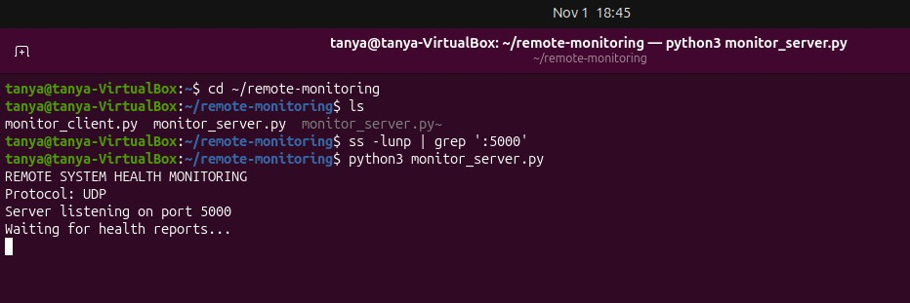
- Client running
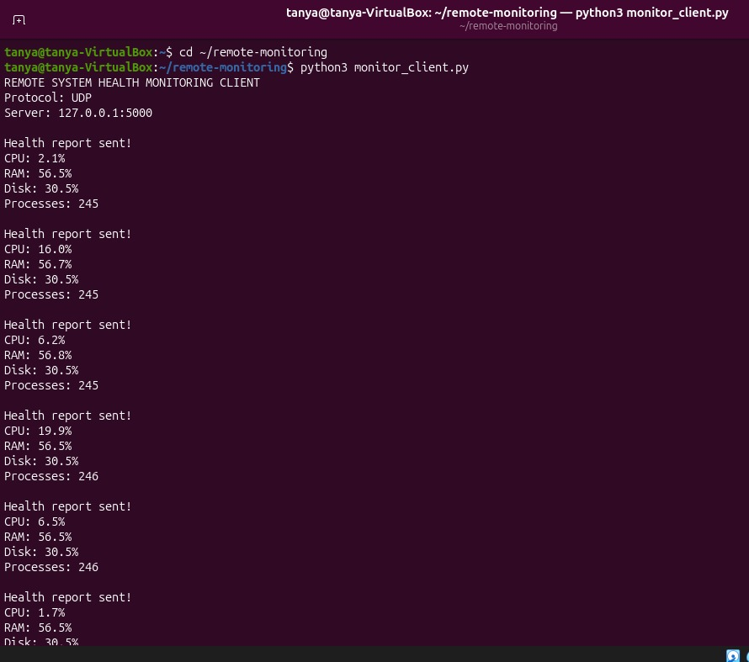

- incoming health reports in the server
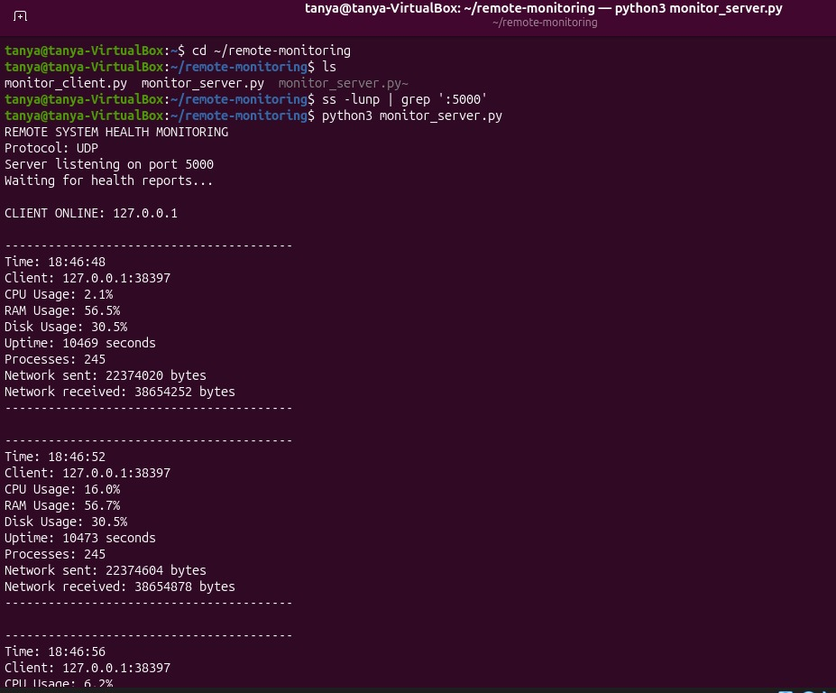

- Both alerts
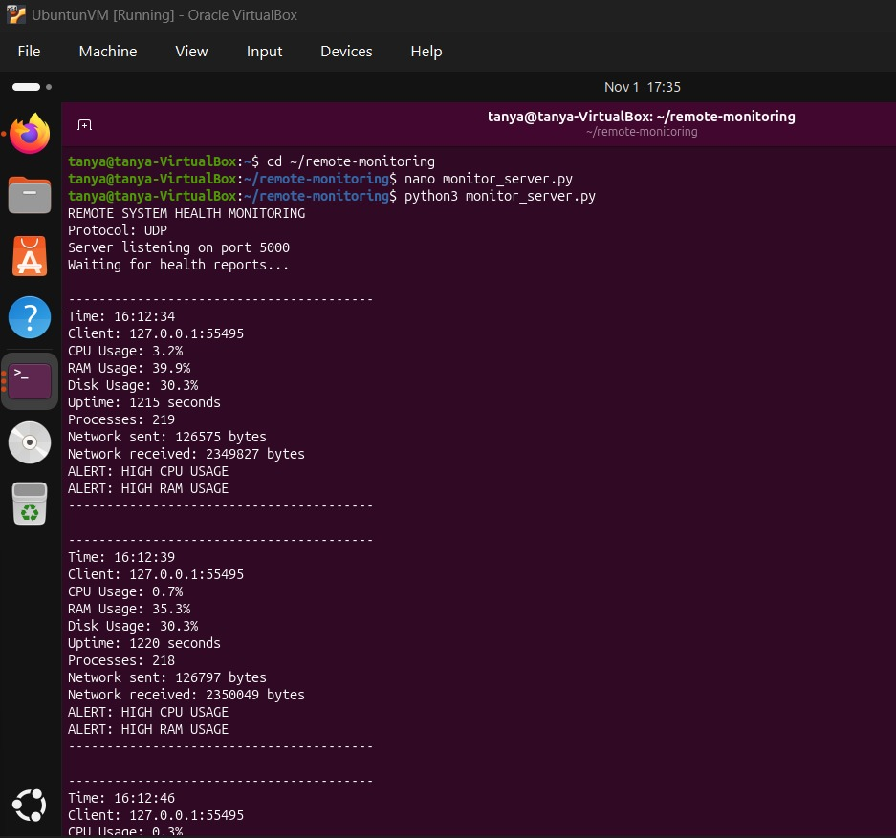

- Offline alert
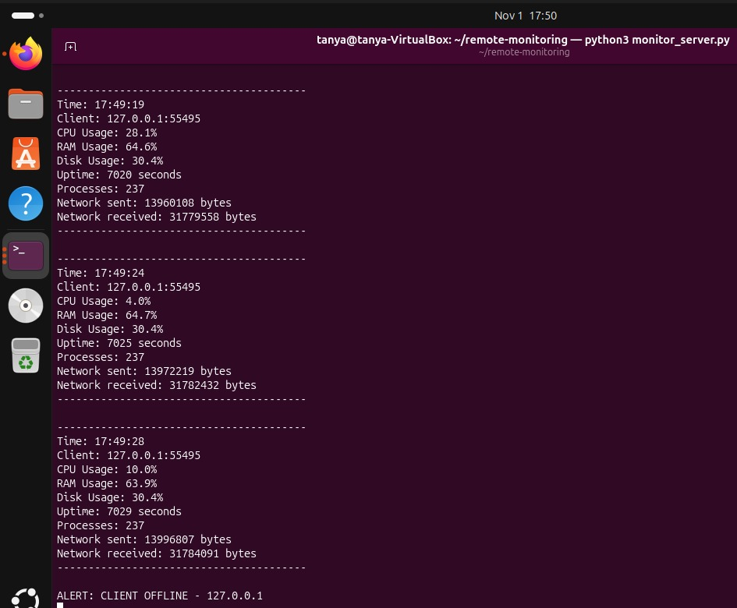

- client recovery
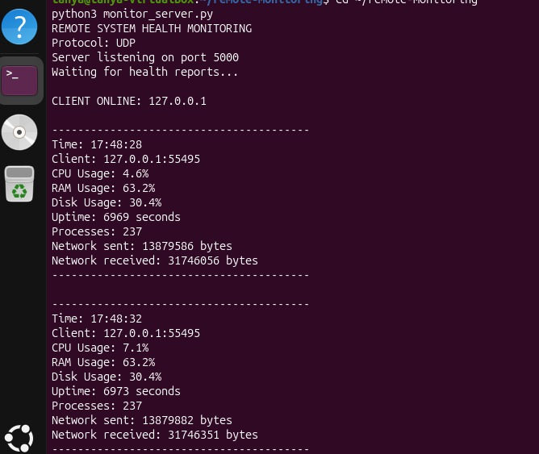
7.ensure no packets are lost
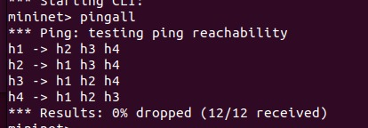
8.ensure pox connected to open vswitch
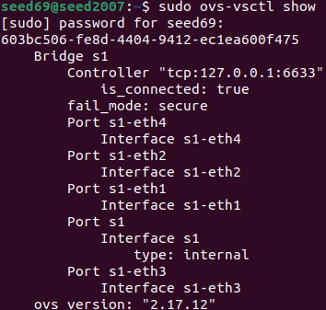
9.OpenFlow rules
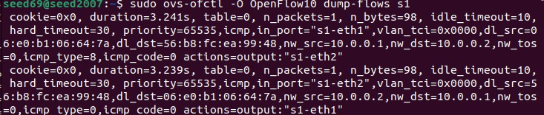

10.UDP report reach the server for 3 different clients
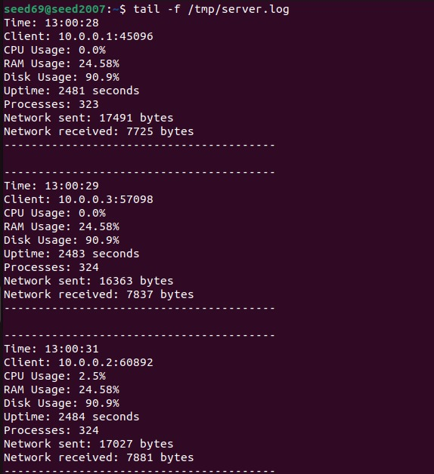
11.Offline detection with multiple clients.
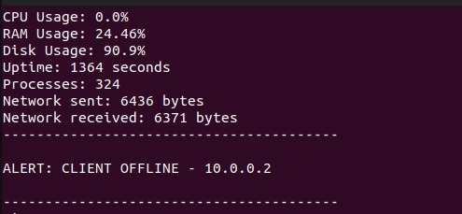

10. Conclusion
The Remote System Health Monitoring project demonstrates how multiple systems can be monitored through a centralized monitoring server.
Python socket programming is used to collect and transmit system health information from monitoring agents to the central server.
Mininet provides a simulated network environment, while Open vSwitch and the SDN controller manage network communication.
The project combines system monitoring, socket programming and Software Defined Networking to demonstrate a centralized approach to monitoring multiple systems.
It also provides an opportunity to understand network communication, system resource monitoring and the integration of software applications with virtual network environments.
Future Enhancements
- Add a graphical dashboard to display monitoring information.
- Store historical system statistics in a database.
- Generate alerts for high CPU and memory usage.
- Monitor more agents.
- Add graphs showing resource usage over time.
- Implement additional security for monitoring messages.

